

Year 9
Semester 2
Investigation 1
Statistical Investigation

Your task is to create an informative poster presentation based on the collection and interpretation of data towards addressing a practical research question for the topic: PERTH VS WORLD.

The poster will be completed in a small group of 2-3 people and all posters will be entered into a national competition. You are to create a poster (up to 84cm by 59cm) on a topic of your own choice. The poster may be presented in either a hard copy or a digital copy. It should be readable from 2 metres away. Your posters will be presented to the class before being sent away for judging in the SSAI competition.

Task Procedure

- Choose a topic question or problem that you will prove or answer using data.

- Complete a plan of action. Use the planning document attached to guide your project to completion.

- State your aim, hypothesis and give some background information.

- Collect the data you require. You MUST use ONLY secondary data taken from a reliable source.

- Produce the data in a table of results.

- Display your data in appropriate graphical forms. (ie. histogram, comparative box plots, scatterplots, dot plot etc.)

- Analyse the data using appropriate techniques (measures of location, measures of spread)

- Discuss the findings of your data analysis clearly outlining any possible biases or outliers and how you have dealt with these issues.

- Complete your conclusion.

- Include references to the sources of your data.

For further information about competition rules and also some great examples;

https://www.ssaipostercomp.info/

Other useful website include;
http://www.abs.gov.au/
https://www.gapminder.org
http://data.gov.au/
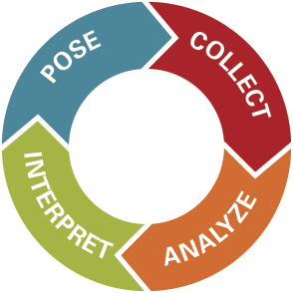

Yr 9 Topic: Perth vs World

The topic for Year 9 is Perth vs World: Your task is to choose a question you would like to answer on any topic that compares Perth with another city or country in the world (it can be more than one city or country). To do this you will need to collect data and use the statistical methods you have learned this year to analyse the data you have collected.

To help you get started, here are some topic suggestions.

- How do mean salaries in Perth compare to the rest of the world?

- How does our school system compare to that of other cities?

- How polluted is Perth compared to the rest of the world?

- How does Perth’s homeless rate compare that of other cities of similar size?

- What has COVID-19’s effect been on Perth compared to other major cities?

- How liveable is Perth compared to the world?

- Does Perth produce more Olympians than other comparable cities?
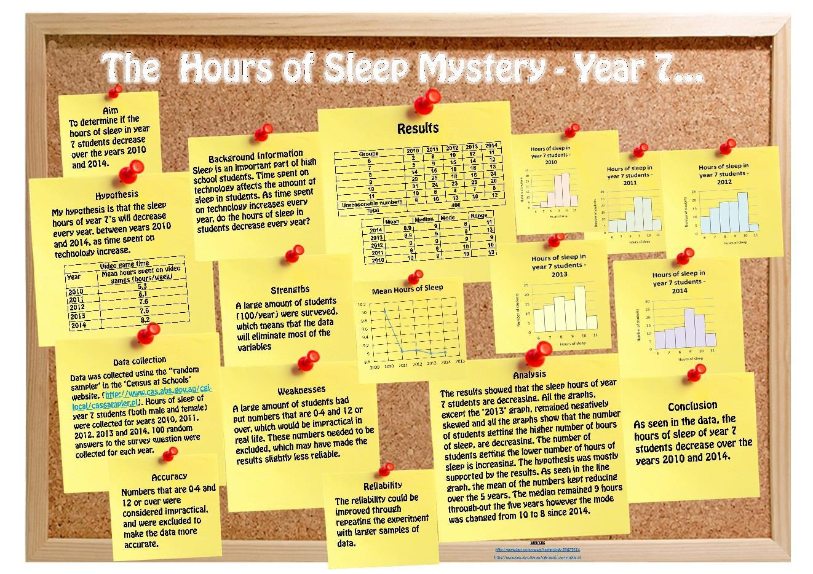
Example

Planning Hints:

A well-considered plan will improve the likely value and success of your project.

Consider the following:

- What types of studies or areas of study may be of interest to you and your team, as well as to others viewing the poster? If it is of interest to you, you will be more motivated to research it and produce a good investigation.

- What is/are the key question/s you wish to address, or hypotheses to test? Can you quantify (with numbers) such hypotheses?

- Can quantitative data (numerical data) be obtained, within your personal constraints and those of the project, that will help you to answer such questions or hypotheses?

- Should, or could, you involve comparisons of groups (e.g., males versus females; between classes; etc.) and in what ways may the groups be compared? This may raise the interest of your project

- If someone else repeated your project would they obtain the same or similar results? Are you attempting to make some generalisations based on a sample?
  - How have you considered variation?
  - How generalised are your results?

- Are you measuring what you intended to measure and need to measure?

- Has everyone involved in collecting data used the same method of measurement and is it the best measure?
  - Why did you measure in a particular way?

- Are you best to report something graphically or via text?
  - does your graph provide a clear message or is it hard to interpret?

- How strong are your conclusions and have you noted limitations and why you were unable to overcome them?

- Is your poster presentation adequately simple and informative?

- Have you used clear headings?

POSTER CHECKLIST

- Clarity of the message:
  - Is the poster understandable without extra information?
  - Are the objectives, research question or hypotheses clear?
  - Are the results and conclusions clear?
  - Is the poster clearly and logically set out?

- Data collection:
  - Are the collected data appropriate for answering the research question?
  - Are the data collection methods clearly stated? (e.g., primary data collection by print, telephone, web survey, or other measurement tools; or secondary sources are cited — published reports, databases etc.)
  - Has quality of the data been considered? (i.e., accuracy of measurements, size of the sample, reliability of sources, methods of sampling, etc.)
  - Has variation been considered when obtaining data?
  - Have comparison groups been considered and well-constructed where applicable?
  - Are the data sources referenced in the poster?
  - Are the survey questions included in the table of results?
  - Has bias in your survey question or sample group been considered?

- Graphs and tables:
  - Are the graphs/tables/statistics appropriate for displaying/summarising the data?
  - Are there adequate graphs/tables from different perspectives?
  - Does every graph/ table add something to the poster?
  - Are the graphs/tables properly titled and explained?

- Calculations
  - Have you included statistical calculations? (ie mean, mode, median, range, etc)

- Analysis and conclusions
  - Are the data analysed in terms of the research question or hypotheses?
  - Is the analysis appropriate for the kind of data collected?
  - How well is the research question answered?
  - Are there conclusions and are they supported by the data?
  - Are there any limitations discussed or improvements for future studies suggested?

- Presentation of poster:
  - Is the poster readable from 2 metres (7 feet) away?
  - Is there a good balance between graphs and text?
  - Does the poster look neat?

- Creativity/importance:
  - Is the research question creative, original?
  - Can the study answer an interesting question?
  - Is the design creative and original?
  - Is the poster eye-catching?

- Presentation of poster:
  - Are you prepared to present the poster to the rest of the class?

